Breakpoints Placed:

Watchlist: 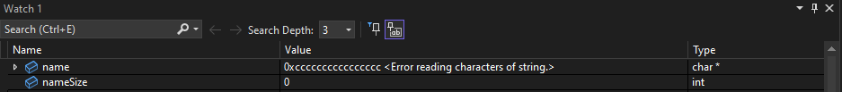

Call Stack:

Debugging Shortcuts:

Ctrl+ f9 = disable breakpoint

Ctrl+ f9 = enable breakpoint

Alt+ f10 = reload

F11 = step into

f10 = Step over

f11 = Step out

Alt+ num= Show next statement

Testing Document:

|  |  |  |  |  |
| --- | --- | --- | --- | --- |
| Test: | Test explanation: | Expected Output: | Actual Output: | Pass or Fail: |
| Loading creating memory Leak | The diagnostics bar will be watched to ensure the amount of memory used does not increase with each input | The amount of memory used will stop increasing after a certain point | Memory stopped increasing after 67mb | pass |
| Trying to go beyond 5 records | The right arrow button will be pressed in attempt to go beyond five record | pressing the right arrow button at the last record will cause the program to not react | The program did not react | pass |
| Name Displayed correctly | Name on UI will be recorded | Name will be displayed correctly | Name was displayed correctly | pass |